FAUSTA DUGO

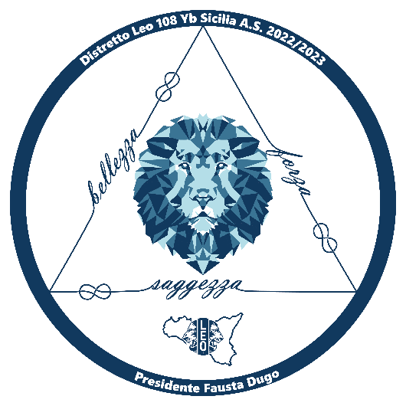 | THE INTERNATIONAL ASSOCIATION OF LIONS CLUBS  DISTRETTO LEO 108 Yb SICILIA  Fausta Dugo  Presidente Distretto LEO 108 Yb  Leo Club Modica II

GABRIELLA GIACINTI

THE INTERNATIONAL ASSOCIATION OF LIONS CLUBS
DISTRETTO LEO 108 Yb SICILIA
Gabriella Giacinti

Chairperson Leo Distretto Lions 108 Yb

Lions Club Palermo Mediterranea

